// program to find the average of 3 nos using method overloding (Instance method).

class Average1

{

static int average (int a, int b, int c)

{

int avg = (a+b+c)/3;

return avg;

}

static float average (float a, float b, float c)

{

float avg = (a+b+c)/3;

return avg;

}

public static void main(String args[])

{

Average obj = new Average();

System.out.println(obj.average(10,20,30));

System.out.println(obj.average(10.5f,20.5f,30.5f));

}

}

Output:

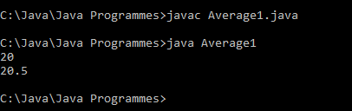

// program to find the area of square, rectangle, circle using method overloding (Static method).

class Areas

{

static int areaSquare (int side)

{

int area = side\*side;

return area;

}

static float areaRectangle(float length, float bredth)

{

float area = length\*bredth;

return area;

}

static float areaCircle(float side)

{

float pie = 3.14f;

float area = pie\*side\*side;

return area;

}

public static void main(String args[])

{

System.out.println("Area of Square "+Areas.areaSquare(10));

System.out.println("Area of Rectangle "+Areas.areaRectangle(10,20.5f));

System.out.println("Area of Circle "+Areas.areaCircle(10));

}

}

Output:

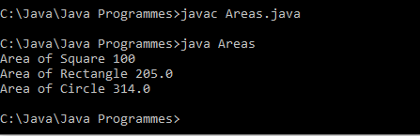

// program to find the area of square, rectangle, circle using method overloding (Instance (Non-Static) method).

class Areas2

{

static int areaSquare (int side)

{

int area = side\*side;

System.out.println("Area of Square "+area);

return area;

}

static float areaRectangle(float length, float bredth)

{

float area = length\*bredth;

System.out.println("Area of Rectangle "+area);

return area;

}

static float areaCircle(float side)

{

float pie = 3.14f;

float area = pie\*side\*side;

System.out.println("Area of Circle "+area);

return area;

}

public static void main(String args[])

{

Areas2 ob1 = new Areas2();

Areas2 ob2 = new Areas2();

Areas2 ob3 = new Areas2();

ob1.areaSquare(10);

ob2.areaRectangle(10,20.5f);

ob3.areaCircle(10);

}

}

Output:

